Project Presentation

ImmoWarrior

PS Software Engineering
WS2001/02

TheTeam:

[GEIERSPICHLER Andrea]
[GROSS Roman]
[POBER Michael]
[RUHS Gunnar]

Academic Supervisor:

Mag. DI Dr. Roland Schwaiger
Initial Assignments

A company that auctions real estates wants us to develop a software-solution for their process of collecting and representing information. (Code: “ImmoWarrior”). Potential users of this system are: the ones, who gather and enter the information and the ones, who want to read it. Those readers can either be persons, or other systems. This leads to two different scenarios:

- Immowarrior sends the information to an other computer system

- Immowarrior displays the information for a person – what requires us to design an appropriate user-interface.

Specially required by the client is, that the software is to be easily maintainable and that no one has to install client-software to be able to use Immowarrior.
For the first phase of the project, we ought to concentrate on the basic-functions of the software, but we should keep the possibility in mind to add expansions, developed in cooperation with our group.

Refinements

During the development of our project some refinements to the problem domain had to be done:

- The client wants the possibility to obtain relevant information on offers via the internet or the mobile phone.
- The information should be sent to the customer either automatically by the system (push) or on individual request (pull).
- The system should provide an access-control-system.
- Private persons receive their username/password by e-mail.
- Private persons have to pay a fee for publishing and viewing information.
- There should be the possibility to include different multimedia-elements (pictures, movies, sounds,…).

Our Method of Solution

As you can see in the deployment diagram we use an architecture based on layers. We distinguish between the following four layers:

- User Interface:

As our system can be accessed by PC or WAP-Handy there are two different ways to connect to the application.

- The user of our system wants to access with a PC:

In that case he runs a browser (e.g. Opera, Netscape Navigator, Internet Explorer…) and connects our system via the corresponding URL (our User Interface - Prototype: http://www.cosy.sbg.ac.at/~mpober/se1/se_html/start.html).

- The user of our system wants to access via handy:

Well, to connect to our system in that way the user has to start the built-in WAP-Browser of the handy. Then he has to enter the corresponding URL (Prototype: http://immowarrior.wap3.de).

- Application/Administration Server:

For the implementation on server-side we want to use a CGI – capable Web-Server (e.g. Apache) and a main CGI-Script which provides the functionality for our users. Our CGI-Script will be an executable file coded in C++ (or Java). This executable on its part accesses the next (theoretical) layer – the Database Interface. In fact, this interface is implemented within this CGI-Script.

- Database Interface:

This layer coordinates the accesses to the underlying database and provides a corresponding interface for the upper layers. We use this layer to separate the main functionality of our application from the lower system accesses to the database although it is coded within the same main executable as the upper layer.

- The Database:

For the data storage the system uses an SQL-capable Database as e.g. Oracle because a database provides data-consistency no matter how many users access it at the same time.

Our Use Cases

The list below shows the main uses cases of our system.

- Viewing Free Offers
- Create New Account:
- Modify Account
- Place a New Real Estate
- Search for Real Estates

Every use case, except the first two, requires a registered user. So these actors differ in the rights they have within the system. A visitor of the home page, who has no account at all, is just allowed to view some free offers and create a new account. A user with read permission is able to view all the offers, whereas a write permission enables you to place a new offer. We actually defined five types of privileges, which can be combined in any way the owner of an account wants.
I just want to explain the last two use cases in detail.

Offer Placing:

When a user with write permission wants to place a new offer he has to visit the homepage and log in. After clicking on the “Insert new real estate” button the system leads him to a page where he can type in the address and specify the type of the real estate. Furthermore, it is possible to give a short description of the building and to upload some multimedia files like videos and audio files.
The new real estate is created and stored in the data base.
Placing an offer is just possible via the HTML browser based version.

Search for Real Estates:

After logging in, a user with read permission is able to view all the offers actually placed in the system. Therefore, he or she opens the “Search for Real Estates” window by clicking on the appropriate button. Now the user can specify some search criteria like state, number of rooms, price… After submitting the input, the system searches the data base and displays the links to the matching real estates in a new window.
The procedure is quite the same for the WML and the HTML model.

The User Interface

In our case, the user interface is based on a simple web-page, that can be accessed with every standard browser via the internet.
When a user visits our homepage he is presented the index screen:
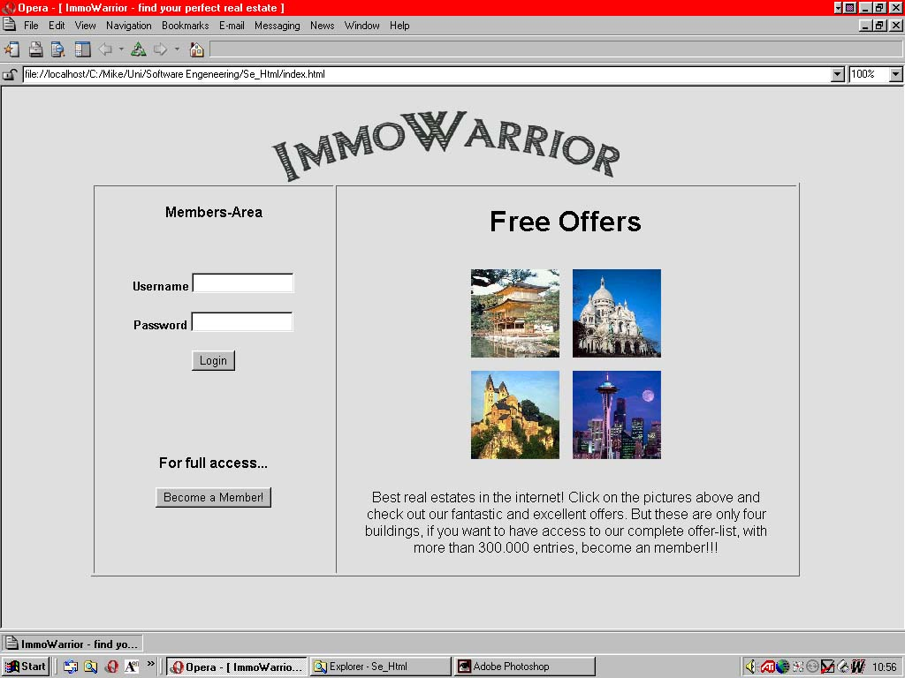

On the right side the free offers are presented. By clicking on an image, the user is transferred directly to the corresponding real-estate entry.
In the left part, at the bottom, is a link for those, who want to become a registered user of the ImmoWarrior system. When they click on the ‘Become a Member!’ Button, they get to a form, where they enter their personal information, their credit card data and their e-mail address, phone number,... Here the users can also select, if and how they want to receive news and updates about ImmoWarrior.
At the upper-left side of the index screen is the entry-point for our members. Here they can submit their username and password and if the data is correct, they get access to our members area.

From the main menu all the features of ImmoWarrior are accessible (all the representations for the use cases we have defined). Only restriction: when a user has limited privileges, he is not presented the entire set of links, but only those, that lead to the areas the user is permitted to enter.

The features are:

Insert a new real estate
The user gets to a form, where he can enter the data for real estates, he wants to offer via ImmoWarrior. Here he can also upload the multimedia data like pictures, videos, sounds,...

Manage your account
The form that is presented is almost similar to the create account form. When the user enters this screen, his account information is entered in the according field so the user is able to change it. The only thing, that he may not alter is his credit card data. Thereby we want to prevent possible misuse of the system.

Search for real estates
This section works as follows. First the user gets to a form, where he enters his search criteria.
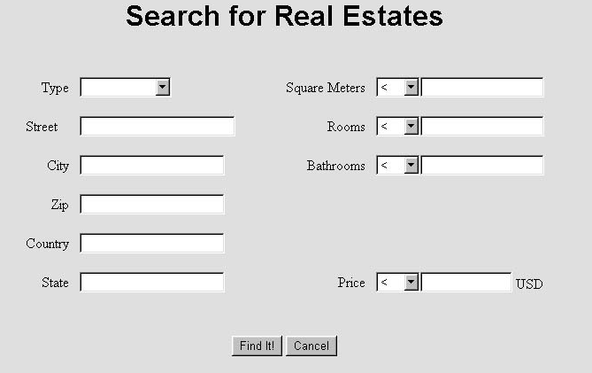

After clicking the ‘Find It!’ button, a new screen appears, that presents the search results. Each result has a short description of the according real estates.

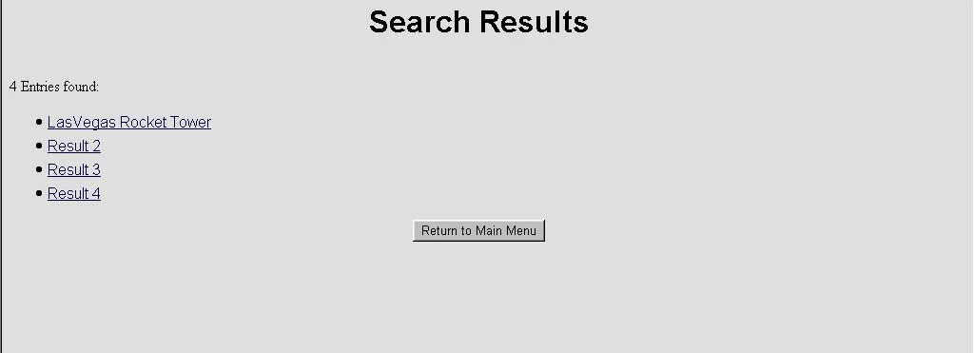

By simply clicking on a search result, a new browser window showing the desired real estate data is opened.
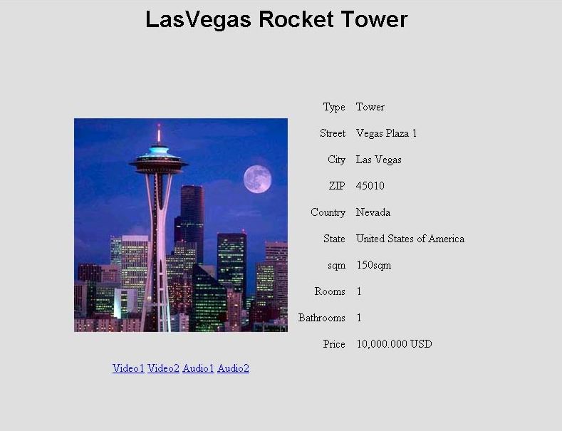

Administration
This last link in the main menu leads to a submenu, that is only accessible for users with admin permissions. This submenu offers special functions concerning the administration of the ImmoWarrior system: “Create new user” and “Modify user account”
These sections look very much like the corresponding areas for ‘normal’ uses but they provide some extensions:
- A set of checkboxes, where an admin can detail the privileges for the accounts.
- The possibility to change the credit card information.
- A “Search for member” function, so that an admin can locate the account he wants to modify.

Advantages and Disadvantages of our Design

Advantages:
- There is no need for a user to install special software to be able to access our system. Our user interface is realized with a webpage, so it can be view with every standard internet browser.
- A user can access our system from any computer connected to the internet at any time he wants to.
- The interface from ImmoWarrior to the database uses standard SQL-queries, so our system is compatible with most of the database systems in use.

Disadvantages:

Our ImmoWarrior system is dependent on tree different components: the Internet, the application server and the database server. If one of these is not working, the whole system is down.

